The Effect of Light Conditions on the Development of *Orius insidiosus*

By: Kaye Puhakka

2A Biology

University of Waterloo

Faculty of Science

The Effect of Light Conditions on the Development of *Orius insidiosus*

Agriculture and Agri-Food Canada, Greenhouse Processing Crops Research Centre

Harrow, Ontario

Kaye Puhakka

20565203

2A Biology

April 1, 2016

2585 County Rd 20

Harrow, Ontario

N0R 1G0

April 1, 2016  
  
Evaluators  
WatPD   
University of Waterloo   
Waterloo, Ontario   
N2L 3G1

Dear Evaluators:  
  
This report, entitled "The Effect of Light Conditions on the Development of *Orius insidiosus*" was prepared as my 2A Work Report for Agriculture and Agri-Food Canada (AAFC).  This is my first work term report. The purpose of this report is to view how rearing insects in LED lighting affects their development.

The Harrow Research Station, operated by AAFC, is committed to being a North American leader in sustainable crops research, employing a minimal pesticide use program.

The Greenhouse Entomology and IPM Research section, in which I was employed, is managed by Rose Labbe and is primarily involved with studying the effects of biological control agents and optimizing their effect on plant pests.  
This report was written entirely by me and has not received any previous academic credit at this or any other institution.  I would like to thank Dana Gagnier for her guidance with insect development and help with data analysis. I also wish to thank my supervisor Rose and my lab-mates for being kind and helpful as I learn the language of entomology.

Sincerely,  
  
Kaye Puhakka

20565203

**Table of Contents**

List of Figures and Tables ……………………………………………......... iii

Summary ……………………………………………………………..………iv

* 1. Introduction ……………………………………………………………… 1

1. Materials and Methods ……………………………………………………3
2. Results …………………………………………………………………….6
3. Discussion and Interpretations ……………………………………………8
4. Conclusions …………………………………………………………..….10
5. Recommendations …………………………………………………...…..10

7.0 Bibliography ……………………………………………………..……... 11

**List of Figures and Tables**

Figure 1. Fourth instar moltskin, left & fifth instar moltskin, right…………….2

Figure 2. Adult soon after molting………………………………………….…..2

Figure 3. Orius Cup Set-Up………………………………………………….... 3

Figure 4. Adult Orius Feeding on Ephestia Eggs……………………………….4

Table 1. Summary of Treatment Conditions…………………………………... 4

Table 2. Development time between instars for each treatment………………..6

Table 3. Average Hind Tibial Length of Adults in Each Treatment……………7

**Summary**

This report focuses on growing the bug *Orius insidiosus* in growth cabinets under several lighting conditions to view how the lights affect the development of the bug. *Orius insidiosus* is commonly used to predate on greenhouse pests and is therefore an important contributor to the greenhouse ecosystem in North America. Newly hatched *Orius insidiosus* were placed into individual cups and separated into seven treatments. The bugs were monitored to see how long it takes for them to develop, and the size of development once adulthood is reached. Summer conditions are shown to most preferable over any other conditions. No developmental size differences were viewed among the treatments. It is recommended that more research go into rearing *Orius insidiosus* under LED supplementary lighting.

**1.0 Introduction**

Growing vegetables year-round in the cold Canadian climate is a difficult task. This endeavor is made even more challenging when pests enter a greenhouse and damage crops. A common pest *Frankliniella occidentalis,* the Western Flower Thrips, causes great damage to plants such as cucumber and sweet pepper (Tommasini & Maini, 1995). Fortunately, the beneficial insect, *Orius insidiosus*, the insidious flower bug, can be used to control populations of these damaging thrips by preying on them (Waite, 2012). *Orius insidiosus* can be reared in a laboratory, with adults ovipositing on beans. Once junveniles hatch, the insects take about ten days to go through their five larval instars and become adults (Castane & Zalom, 1994). However, this bug is greatly affected by light conditions and can sometimes become dormant during the winter months. This is very inconvenient for the control of greenhouse crop pests because they are ineffective at doing their job. In order for the insidious flower bug to be effective at its job in controlling pests, it must be able to grow to an adult and reproduce. The faster a bug is able to grow and reproduce, the more pest-fighting power the species has. This assay aims to test how quickly the species *Orius insidiosus* is able to grow to an adult in seven different lighting treatments. The most successful treatment conditions can then be applied to greenhouse systems in which this species is being used. *Orius insidiosus* hatches from an egg and goes through five larval instars before becoming an adult (Waite, 2012). Each larval instar differs by size and colour patterns and will shed a molt skin between 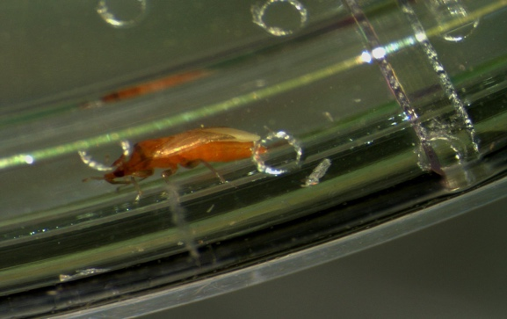each larval stage and before becoming an adult.

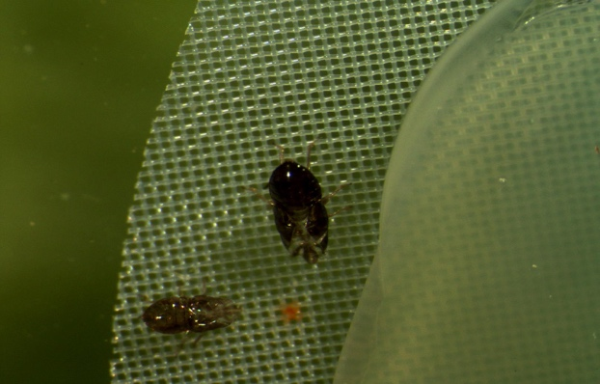

Figure 1. Fourth instar moltskin, left & fifth Instar moltskin, right (Burton & Puhakka, 2016)

Figure 2. Adult soon after molting (Burton & Puhakka)

The time between molts (in days) will be monitored to determine the best lighting condition for development. *Orius insidiosus* tends to develop the best under summer lighting conditions and this is expected to be a leading treatment in this study (Ruberson et al., 1991). The tibia lengths of the third leg will be measured for each insect and used as a measurement of developmental success. This will view whether or not the treatments produce insects that are the same size, and have therefore, developed equally well.

**2.0 Materials and Methods**

In this assay, newly hatched juveniles must be used. Several adults are placed in a cup with a green bean in each of the seven treatments. The insect eggs are then oviposited onto the beans by the female and the beans are collected for use in this experiment (Waite, 2012). After hatching, insects are grown in individual circular cups, each with a circle of inverted pepper leaf on top of water agar. The pepper provides plant material for the bug to live on, and the water agar keeps the leaf fresh and moist, and helps to control humidity. The cup’s lid has a circle of mesh in the top to allow air flow to the insect and to reduce condensation in the cup. The agar, leaf and cup are all sterilized before use to avoid growth of bacteria and fungus while in the growth cabinet. Twenty millilitres of autoclaved agar is dispensed 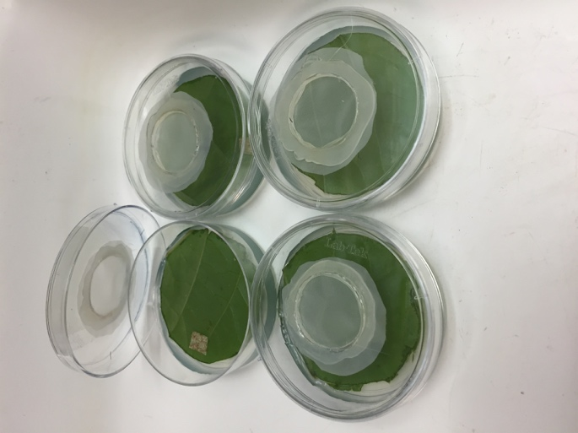into the bottom of each cup, and a cut pepper leaf disk is placed inverted on the molten agar. Once the agar cools, after an hour, an insect can be placed on the leaf disk. Each cup receives one newly hatched insect as well as a portion of *Ephestia kuehniella* (moth) eggs. The *Orius* will feed on the eggs through all of its larval instars and during adulthood (Waite, 2012). The lid is sealed to the base using parafilm. All outside edges of the cup must be firmly sealed to avoid escape of the insect, as they are very small and quick. During this initial period, the juveniles will be in their first instar (N1).

Figure 3. Orius Cup Set-Up (Burton & Puhakka)

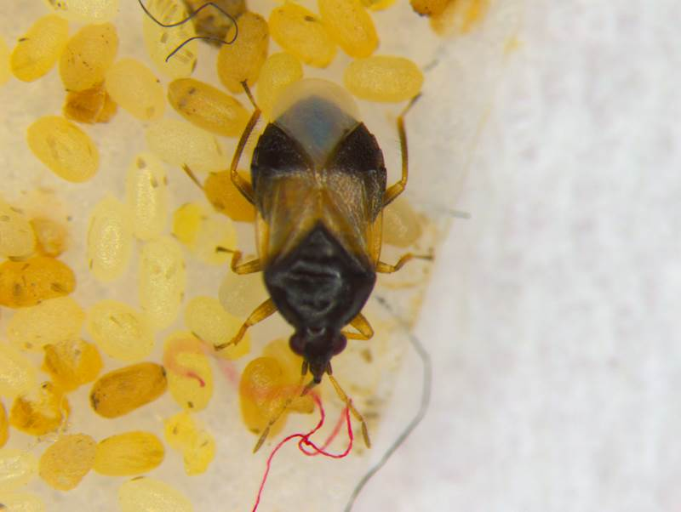

Figure 4. Adult Orius feeding on Ephestia Eggs (Puhakka, 2016)

Once the insects are prepared in their cups, they are placed in seven different treatments (in isolated growth cabinets). The treatments include Low Red, Low Blue, High Red, High Blue, Summer, Winter, and High Pressure Sodium. Low Red, Low Blue, High Red, and High Blue are all lit by LED light. The difference between Low Red and High Red is the vertical distance between the bug and the LED light (the same logic is applied to Blue). High Pressure Sodium is a common type of light used in commercial greenhouses. Summer and

Winter are lit using both fluorescent and incandescent light. They differ by the photoperiod (length of time the light is on) and intensity of the light. These cabinets are used to replicate summer and winter conditions within a greenhouse. Conditions in each of the seven treatments are summarized below.

|  |  |  |  |  |  |  |
| --- | --- | --- | --- | --- | --- | --- |
| Treatment | Temp (ᴼc) | Light Intensity  (W/m2) | Hours of Light Per Day | Time Light On | Time Light Off | |
| HPS | 20 | 11 | 8 | 8 | 16 |
| Summer | 24 | 83 | 16 | 5 | 21 |
| Winter | 20 | 11 | 8 | 8 | 16 |
| Low Blue | 20 | 2.7 | 20 | 4 | 24 |
| Low Red | 20 | 2.7 | 20 | 4 | 24 |
| High Blue | 20 | 11 | 20 | 4 | 24 |
| High Red | 20 | 11 | 20 | 4 | 24 |

Table 1. Summary of Treatment Conditions (Gagnier, 2016)

Once the insects are prepared in their individual cups, they will be placed in their respective cabinets for the duration of the experiment. The insects will be sampled every twenty four hours and be monitored for molting. Every time an individual molts, the date will be recorded on a data sheet. Also recorded is any deaths, nature of the death and escapes. This data will be recorded until the insect’s final molt, when it becomes an adult. Once the bug is an adult, the sex of the insect will be determined and the insect will be preserved in ethanol. The bugs will then be sampled and the lengths of each of their hind-tibias will be measured. This is used as a measure of growth size and growth success.

**3.0 Results**

|  |  |  |  |  |  |  |  |
| --- | --- | --- | --- | --- | --- | --- | --- |
| **Treatment** |  | **Time** | **Time** | **Time** | **Time** | **Time** | **Time** |
|  |  | **N1-N2(days)** | **N2-N3(days)** | **N3-N4(days)** | **N4-N5(days)** | **N5-Adult(days)** | **N1-Adult(days)** |
|  |  |  |  |  |  |  |  |
| **Low Blue** | **Average:** | **1.14** | **2.36** | **2.95** | **2.64** | **7.00** | **16.09** |
|  | S.E.: | 0.136 | 0.287 | 0.372 | 0.244 | 0.486 | 0.513 |
|  |  |  |  |  |  |  |  |
| **Low Red** | **Average:** | **1.00** | **3.75** | **3.75** | **3.25** | **5.75** | **17.50** |
|  | S.E.: | 0.000 | 0.750 | 0.854 | 0.629 | 0.946 | 0.289 |
|  |  |  |  |  |  |  |  |
| **High Blue** | **Average:** | **1.61** | **2.00** | **2.28** | **3.33** | **8.11** | **17.33** |
|  | S.E.: | 0.741 | 0.866 | 1.349 | 1.414 | 2.261 | 2.121 |
|  |  |  |  |  |  |  |  |
| **High Red** | **Average:** | **1.35** | **1.95** | **2.90** | **3.60** | **7.30** | **17.10** |
|  | S.E.: | 0.183 | 0.353 | 0.348 | 0.777 | 0.517 | 0.657 |
|  |  |  |  |  |  |  |  |
| **HPS** | **Average:** | **1.21** | **1.83** | **3.04** | **3.33** | **8.00** | **17.42** |
|  | S.E.: | 0.144 | 0.278 | 0.494 | 0.414 | 0.444 | 0.621 |
|  |  |  |  |  |  |  |  |
| **Summer** | **Average:** | **1.00** | **1.44** | **1.94** | **1.91** | **1.88 \*** | **8.18 \*** |
|  | S.E.: | 0.043 | 0.104 | 0.160 | 0.220 | 0.169 | 0.287 |
|  |  |  |  |  |  |  |  |
| **Winter** | **Average:** | **1.29** | **2.29** | **2.14** | **3.14** | **7.57** | **16.43** |
|  | S.E.: | 0.184 | 0.184 | 0.143 | 0.143 | 0.685 | 0.685 |

Table 2. Development time between instars for each treatment

The above figure demonstrates how long *Orius* spent in each instar (N) under each treatment, and how long it took to grow to an adult from hatching. The day that the bugs became first instar (N1) represents the day of hatching from the egg. The standard error (S.E.) of each is also shown. The presence of an asterisk (*) denotes that the value differed statistically significantly from the values in other treatments.

|  |  |  |  |
| --- | --- | --- | --- |
|  |  | **Tibia** |  |
| **Treatment** |  | **length (mm)** | **n** |
|  |  |  |  |
| **Low Blue** | **Average:** | 0.52 | **7** |
|  | S.E.: | 0.020 |  |
|  |  |  |  |
| **High Blue** | **Average:** | 0.54 | **5** |
|  | S.E.: | 0.023 |  |
|  |  |  |  |
| **High Red** | **Average:** | 0.57 | **6** |
|  | S.E.: | 0.014 |  |
|  |  |  |  |
| **HPS** | **Average:** | 0.52 | **9** |
|  | S.E.: | 0.013 |  |
|  |  |  |  |
| **Summer** | **Average:** | 0.50 | **4** |
|  | S.E.: | 0.047 |  |

Table 3. Average Hind Tibial Length of Adults in Each Treatment

Table 3 summarizes the measured length of the hind tibia of adults in each treatment. These measurements were ascertained using a calibrated dissecting microscope with a measure tool attached to the ocular lens. These measurements were done at 50x magnification. The standard error (S.E.) for each value is also shown. The number of specimens measured is denoted by “n”. Lo Blue and Winter do not yet have any data because they have yet to be measured.

**4.0 Discussion and Interpretation**

The goal of this study is to view what condition(s) the bug *Orius insidiosus* develops best in. This report focuses on two facets of its development; time and size. Hind tibial lengths were averaged from treatments where adults were successfully able to grow. The lengths of the tibia were all quite consistent, having no statistically significant difference in length. Therefore, it appears that the lighting condition does not directly affect the size that the bug is able to grow to. The insects in every treatment measured were able to grow to full size adults. In terms of size, there were no differences in the success of development among the treatments. However, size is not a guarantee of viability of insects, and dissection of sexual organs can provide another measure of developmental success. More observation and data collection is needed in this area.

There were differences in the time it took for the bug to develop in different lighting treatments. The insects tended to develop at approximately the same speed for the first four instars (N 1-4) regardless of the treatment. There was no significant difference in days spent in each instar between all the treatments. However, insects that were growing in summer were able to proceed through the fifth instar stage, becoming an adult, 3-7 days sooner than the other treatments. This leads to a much shorter overall developmental time for summer, averaging about half that of the other treatments. This observation makes summer the most successful treatment, however, summer conditions are not always able to be replicated in a greenhouse context. High Pressure Sodium (HPS) is a very commonly used light source in many commercial and research greenhouses. The purpose of the other treatments is to test an alternative to summer conditions so that the bug can be reared quickly and successfully any time of the year. Unfortunately, there seemed to be no significant effect of supplemental LED lighting on the speed of development of *Orius insidiosus.* The addition of supplemental lighting neither hindered nor helped the development of the bugs and was not significantly different from winter or regular HPS conditions. This means that if supplemental LED lights are being used in a greenhouse, for plant growth or other purposes, they will not hinder the insect’s ability to develop fully. However, the results show that more research is needed for the use of LED lighting as a possible positive impact on the development of *Orius insidiosus.* The treatment showing the most current promise is Lo Blue light, as it shows the fastest developmental time after summer. Currently, the differences between Lo Blue and Winter are marginally significant, and more repetitions will be needed to make a conclusion.

**5.0 Conclusions**

*Orius insidiosus develops to approximately the same size.*

Despite differences in light colour and intensity in different treatments, all adults grow to be about the same size, based on the length of their hind tibias.

*Summer is the most effective treatment for rearing Orius insidiosus.*

In the Summer treatment, the bugs developed twice as fast as other treatments.

*HPS, Winter and Supplemental lighting conditions do not show significantly different growth times.*

Under these treatments, all developed to full adults in about the same time, indicating that none of these treatments are more advantageous than the other.

**6.0 Recommendations**

*If possible, rear Orius insidiosus in summer conditions.*

By having the bug mature in summer conditions, there is a dramatic decrease in maturation time, allowing the grower to have reproductively mature adults much sooner. If possible, *Orius insidiosus* should be kept in a summer condition greenhouse or grown in a summer condition cabinet and then released into a greenhouse for control of *Frankliniella occidentalis.*

*More data should be collected on development time in supplemental LED lighting.*

Although no significant differences were viewed among LED treatments, blue light has shown to be a promising option. Further research will greatly enhance the ability to make conclusions in this area.

**7.0 Bibliography**

Burton, E., Puhakka, K. (Photographers). (2016). Fourth instar moltskin, left & fifth instar moltskin, right [Photograph]. Harrow, Ontario: Agriculture and Agri-Food Canada.

Burton, E., Puhakka, K. (Photographers). (2016). Adult soon after molting [Photograph]. Harrow, Ontario: Agriculture and Agri-Food Canada.

Burton, E., Puhakka, K. (Photographers). (2016). Orius Cup Set-Up [Photograph]. Harrow, Ontario: Agriculture and Agri-Food Canada.

Castane, C., & Zalom, F. G. (1994). Artificial oviposition substrate for rearing Orius insidiosus (Hemiptera, Anthocoridae). *Biological control*, *4*(1), 88-91.

Gagnier, D. (2016). Summary of Treatment Conditions. Agriculture and Agri- Food Canada. Harrow, Ontario.

Puhakka, K. (2016). Adult Orius feeding on Ephestia Eggs. Agriculture and Agri-Food Canada. Harrow, Ontario.

Ruberson, J.R., Bush, L., Kring, T.J. (1991). Photoperiodic Effect on Diapause Induction and Development in the Predator Orius insidiosus (Heteroptera: Anthocoridae). Department of Entomology, University of Arkansas. DOI: 10.1093/ee/20.3.786

Tommasini, M. G., & Maini, S. (1995). Frankliniella occidentalis and other thrips harmful to vegetable and ornamental crops in Europe. *Wageningen Agricultural University Papers*, (95-1), iii+-1.

Waite, M. (2012). New Strategies to Improve the Efficiency of the Biological Control Agent, Orius insidiosus (Say), in Greenhouse Ornamental

Crops. Department of Environmental Biology, University of Guelph.